5 CLASSY ELEGANT VALENTINE’S DINNER OUTFITS FOR EVERY VIBE

Valentine’s Day is right around the corner and you need to look your best. Finding the right look for a fancy night out can feel stressful but it should be fun. You want to feel confident while you sip wine and eat dessert. This year is all about looking polished and feeling amazing in your skin. I found the best 5 Classy Elegant Valentine’s Dinner Outfits for Every Vibe to make your planning easy. If you have a reservation at a fancy restaurant or a cozy candlelit spot, these looks will work. Grab your favorite heels and get ready to turn heads all night long. Check out these looks below.

# Red Silk Slip Dress

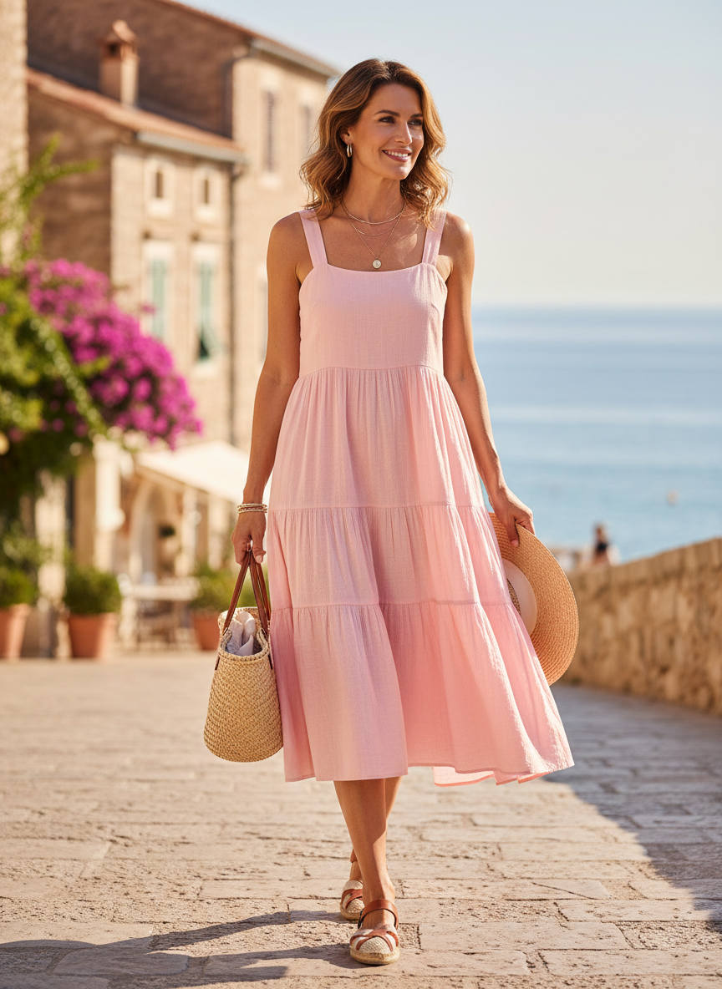

A red silk slip dress is the ultimate classic for a romantic evening. The fabric catches the light perfectly and feels so soft against your skin. You can pair it with some gold jewelry and thin strappy heels to keep the look clean. It is a simple way to look high fashion without trying too hard. This outfit is perfect for a fancy dinner where you want to feel beautiful.

# Black Velvet Jumpsuit



A black velvet jumpsuit is a total power move for your date night. The rich texture makes it look expensive and chic immediately. You will stay warm while looking incredibly sophisticated. Add a belt to cinch your waist and show off your shape. This look is perfect if you want to stand out from the crowd of dresses. It is comfortable enough to wear through a long meal but looks very formal.

# White Satin Midi Skirt



A white satin midi skirt offers a fresh and bright take on holiday style. You can pair it with a fitted cream sweater for a monochrome look that screams quiet luxury. The way the satin moves as you walk creates a very graceful silhouette. It is one of those 5 Classy Elegant Valentine’s Dinner Outfits for Every Vibe that works for any upscale location. Keep your accessories minimal to let the clean lines of the skirt speak for themselves.

# Pink Lace Bodycon Dress

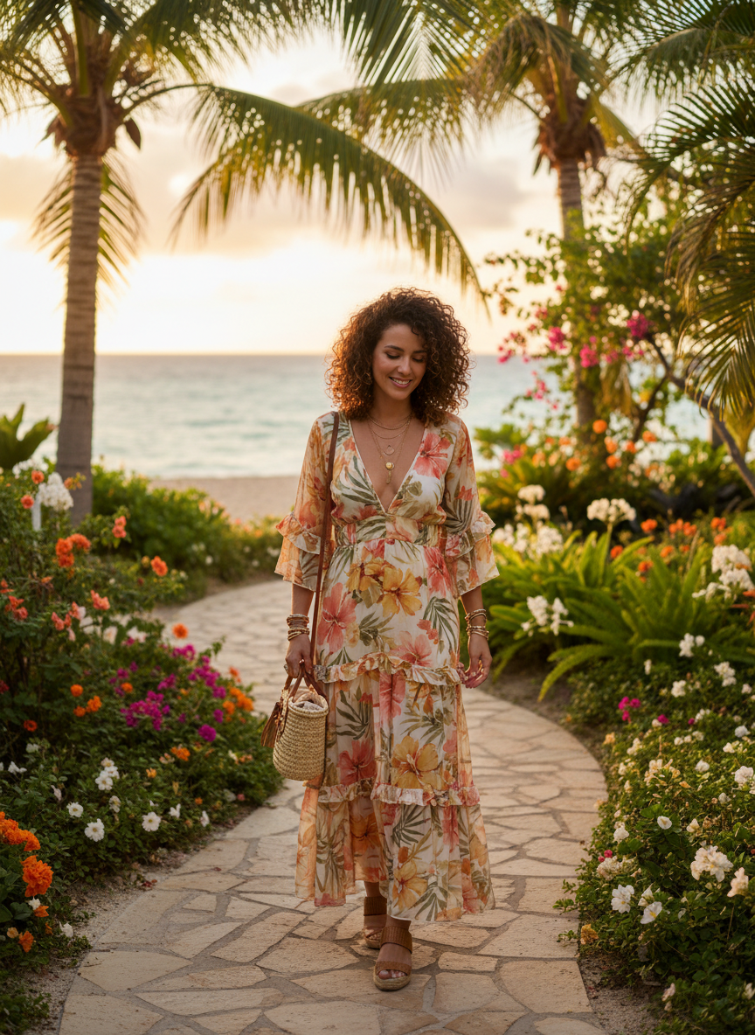

A pink lace bodycon dress brings a feminine and soft energy to the table. The intricate details of the lace make the outfit look very detailed and thoughtful. Pick a muted rose or dusty pink to keep it looking mature and elegant. This dress hugs your curves in all the right places while still looking modest. Pair it with nude pumps to elongate your legs and keep the focus on the beautiful fabric.

# Off the Shoulder Long Sleeve Dress

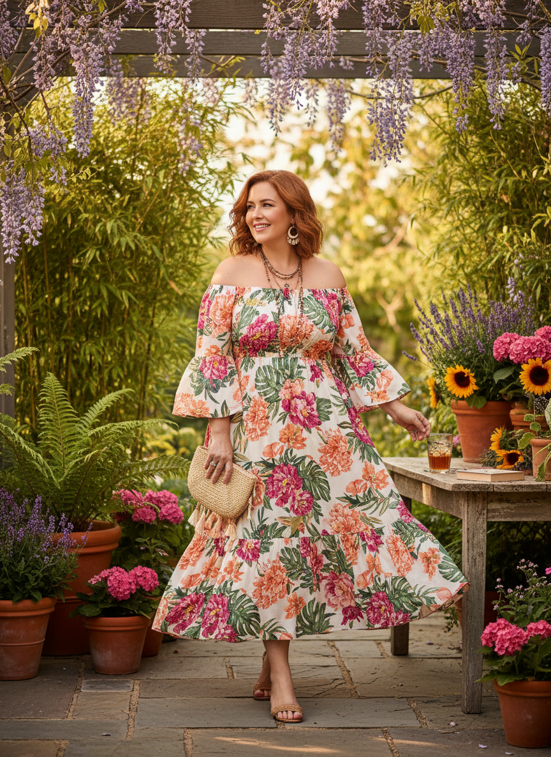

An off the shoulder long sleeve dress is the perfect balance of sexy and class. Showing a little bit of shoulder keeps things interesting while the long sleeves add a formal touch. Go for a deep burgundy or a classic navy blue to match the evening mood. It is a timeless choice that will look great in all your dinner photos. You will feel so poised and ready for a special night out.

# Conclusion

Your Valentine’s Day look should make you feel like the best version of yourself. These outfits are all about being timeless and chic while you celebrate love. You deserve to feel stunning and comfortable during your special dinner. Pick the vibe that fits you best and enjoy the night. Save these ideas to your Pinterest board now.